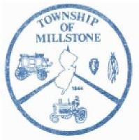
TOWNSHIP OF MILLSTONE
Construction Department
County of Monmouth
Dennis Gibson, Construction Official 470 Stagecoach Road Millstone Township, NJ 08510 Phone (732) 917-2953 Fax (609) 208-2083

Demolition
Complete Permit Application should include:
- Construction Permit Application forms filled out completely by contractor.
- Copy of survey and zoning application filled out completely.
- Release from all utility companies that service connection has been removed or made
safe.
❑ Gas company
❑ Electric company
❑ Monmouth County Health Department (well capped and septic abandonment)
732-431-7456
❑ Proof of removal or abandonment of oil tank or permit to remove.
❑ Oil tank removal.
- Letter from exterminator indicating proper rodent baiting.
- Copy of Home Improvement Contractors Registration.
- Approval from Freehold Soil 732-683-8500
Required inspections
Backfill (when foundation is removed)
Final building inspections
Final fire if oil tank is present
All dump/disposal receipts from licensed hauler and/or scrap metal dealer.
Rev. 1/20 Demo Requirements

